Level 0.1: Microcontroller Fundamentals

0.1.1 What exactly is a microcontroller?
Let's start with a simple definition:
A microcontroller (MCU) is a complete small computer integrated into a single chip, designed primarily to interact with and control hardware.
That sentence has several important pieces.
A typical MCU contains:
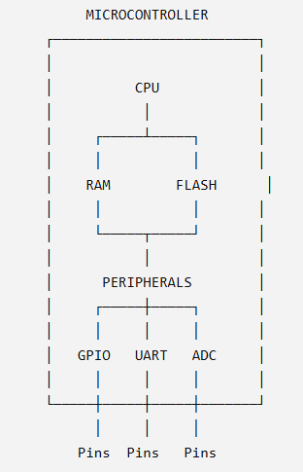
So an MCU isn't just a CPU.
It combines:
CPU + memory + peripherals + communication infrastructure + clock/reset circuitry + I/O
on one chip.

0.1.2 Why do we need a CPU?
The CPU is the part that executes instructions.
Suppose your program says:
LED = ON;
The CPU doesn't inherently understand the English idea "LED ON."
Your C code gets transformed by the compiler into machine instructions.

Conceptually:
C program
↓
Compiler
↓
Machine instructions
↓
CPU executes instructions
The CPU performs operations such as:
- LOAD
- STORE
- ADD
- SUBTRACT
- AND
- OR
- COMPARE
- BRANCH
But here's an important question:
Can the CPU itself directly sense a temperature sensor?
No.
Can the CPU itself directly drive a motor?
No.
Can the CPU itself generate a UART waveform?
Not by itself.
That's where peripherals enter the picture.

0.1.3 What is a peripheral?
A peripheral is a hardware block inside the MCU that performs a specialized function.
For example:
- GPIO → digital input/output
- ADC → analog → digital conversion
- UART → serial communication
- SPI → synchronous serial communication
- I²C → two-wire communication
- TIM → timing/PWM
- CAN → CAN communication
Instead of making the CPU manually perform every electrical operation, dedicated hardware does much of the work.
Think of the CPU as the manager, and peripherals as specialized departments.
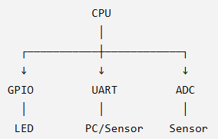
The CPU configures the peripheral and tells it what to do.
Then the peripheral interacts with the outside world.

0.1.4 What is memory?
Your MCU needs somewhere to store:
- The program
- The data the program is currently working with
This is why we have different types of memory.
The two you'll encounter constantly are:
Flash
Generally used to store:
- Program code
- Constant data
It is non-volatile, meaning the contents remain when power is removed.
So when you turn your STM32 off and turn it back on, your program is still there.
RAM
Used for temporary runtime data.
For example:
int temperature = 25;
That variable needs memory while your program is running.
RAM is volatile.
Power disappears:
Power OFF
↓
RAM contents lost

0.1.5 So what's actually inside an MCU?
At a high level:
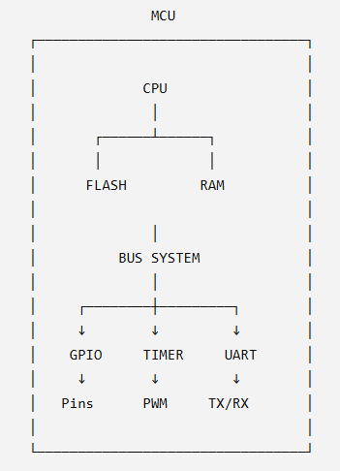
This picture is worth understanding rather than memorizing.

0.1.6 MCU vs Microprocessor
This distinction is important.
You have already used things like Arduino and ESP32, so you've interacted with MCUs.
A microprocessor (MPU) generally focuses on the processing core and relies much more heavily on external components.
A simplified comparison:
 | Microcontroller | Microprocessor
CPU | Inside chip | Inside chip
RAM | Usually integrated | Often external
Program storage | Often integrated | Often external
GPIO | Usually integrated | Often through external/peripheral controllers
Timers | Integrated | Often additional hardware
ADC | Common in MCUs | Not necessarily present
Typical use | Control systems | General-purpose computing
For example:
MCU

┌──────────────────────┐
│ CPU │
│ RAM │
│ Flash │
│ GPIO │
│ ADC │
│ Timers │
│ UART │
└──────────────────────┘
ONE CHIP
Whereas a simplified MPU system looks more like:
┌───────────┐
│ CPU │
│ MPU │
└─────┬────┘
│
┌────────┼─────────┐
↓ ↓ ↓
RAM Storage Peripherals
This is one reason MCUs are so useful for embedded control.

0.1.7 Let's use something you already know
Take the Arduino Uno.
At its heart is an ATmega328P microcontroller.
The Arduino board isn't itself the microcontroller.
It's a development board built around a microcontroller.
Conceptually:
Arduino Uno
│
├── ATmega328P MCU
├── USB interface
├── Voltage regulation
├── Crystal/clock
├── Connectors
└── Other supporting components
Same idea with your future Blue Pill:
Blue Pill board
│
├── STM32F103C8T6 MCU
├── Crystal
├── Voltage components
├── Reset circuitry
├── USB-related components
└── Headers
This distinction is important:
STM32 is the MCU family. Blue Pill is a development board containing an STM32 MCU.

0.1.8 Now let's introduce the most important concept
Imagine this:
Your STM32 has a GPIO peripheral.
The CPU needs to tell GPIO:
"Make pin PA5 HIGH."
How does the CPU communicate with GPIO?
Not through some magical function called GPIO_Write().
There is hardware sitting at an address.
For example, conceptually:
CPU
↓
write a value
↓
Memory address
0xXXXXXXXX
↓
GPIO register
↓
GPIO hardware
↓
PA5
↓
Voltage changes
↓
LED
This is called:
Memory-mapped I/O
And this concept is going to become one of the foundations of our STM32 journey.
We'll spend significant time on it in the next section.

0.1.9 The three worlds of embedded engineering
I want you to start thinking in three layers:
Software
GPIOA->ODR |= ...
Hardware architecture
CPU
↓
Bus
↓
GPIO peripheral
↓
GPIO register
Physical world
Register bit
↓
GPIO output driver
↓
Pin voltage
↓
LED turns ON
A strong embedded engineer can move between all three.

Checkpoint 1:
Q1
What is the difference between:
MCU, microprocessor, and development board?
Use Arduino Uno / any other board as an example.
Q2
Imagine an STM32 program needs to:
Read a temperature sensor
Process the temperature
Send the result to a PC
Turn a fan ON/OFF
Which parts of the MCU would you expect to be involved?
Try to map them:
Temperature sensor → ?
Processing → ?
PC communication → ?
Fan control → ?
Program storage → ?
Runtime variables → ?

Q3
Why can't we simply say:
"The CPU controls the LED directly"?
What hardware sits between the CPU and the physical LED?

Q4
Suppose I tell you:
Address: 0x40000000
What do you currently think an address means?

Q5
Here's the important reasoning question.
Imagine we have:
CPU ─────── GPIO ─────── LED
The CPU executes:
GPIO_REGISTER = 1;
What do you think physically happens between the CPU executing that instruction and the LED turning ON?

Evaluation: https://chatgpt.com/share/6aa76db8-6584-83ee-8257-a7bb7921d8a4

